MAKING
AMAZING
KIDS
STRONGER
‘FRIDAYS IN MOTION’
Adaptive Sports Open Gym & Swim

At Fridays in Motion, children living with autism and their families join together at the YMCA of Austin for two hours of play and recreation!
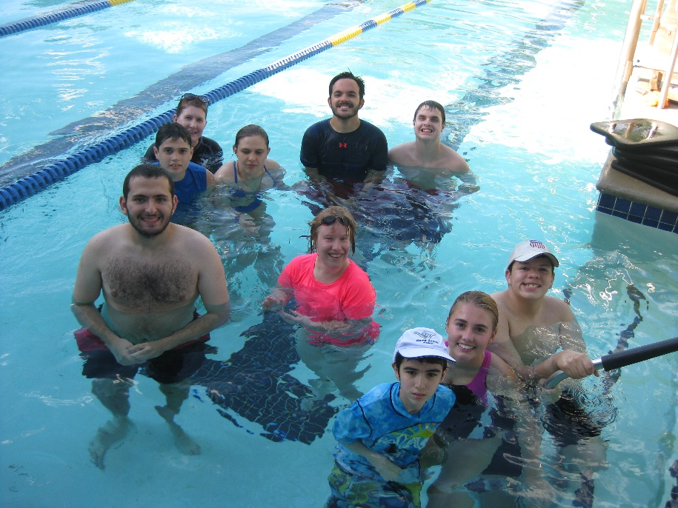
WHEN: 3rd and 4th Friday of April

WHERE: Townlake YMCA
TIME: 6:30-8:30pm

For more information contact Sam Skurka at 512.891.9622 or AustinYMCA.org

